Northern New England Society for Healthcare Risk Management (NNESHRM) Sponsorship Opportunities

About NNESHRM

The Northern New England Society for Healthcare Risk Management (NNESHRM) is a 501(c)(6) nonprofit organization dedicated to supporting healthcare risk managers, patient safety professionals, defense attorneys, insurance professionals, and medical-legal consultants. Our mission is to help minimize liability risks for healthcare providers across Maine, New Hampshire, and Vermont. NNESHRM is an independent chapter of the American Society for Healthcare Risk Management (ASHRM).

Our Mission

NNESHRM is committed to advancing healthcare risk management and patient safety through education, networking, and knowledge-sharing. We support the professional development of our members while promoting best practices in risk mitigation and patient safety.

Why Sponsor NNESHRM?
Sponsorship provides a unique opportunity to connect with healthcare risk management professionals while supporting NNESHRM’s mission. Your contribution helps fund educational programs, networking events, and member resources, allowing us to keep membership costs accessible. Sponsors also receive valuable recognition and engagement opportunities to showcase their commitment to healthcare risk management.

Sponsorship & Payment Options
You can sponsor and pay online at: https://nneshrm.org/sponsors
Or, complete the form on the next page and email it to: sponsorship@nneshrm.org

Sponsorship Levels & Benefits
Core Benefits (Included with All Sponsorships)
- Logo featured on a "Thank You Sponsors" slide at both in-person education days.
- Logo displayed on the NNESHRM Website Sponsor Page.
- Annual recognition on the NNESHRM Chapter LinkedIn page

Diamond Sponsor – $2,500
Includes Core Benefits, PLUS:
- Company logo with a website link on the NNESHRM website landing page and Sponsor Page.
- Three (3) complimentary individual NNESHRM memberships.
- Opportunity to introduce a speaker at one education day.
- Priority consideration for speaker proposals (if submitted within deadlines).

Platinum Sponsor – $1,750
Includes Core Benefits, PLUS:
- Two (2) complimentary individual NNESHRM memberships.
- Opportunity to introduce a speaker at one education day.

Gold Sponsor – $1,000
Includes Core Benefits, PLUS:
- One (1) complimentary individual NNESHRM membership.

Silver Sponsor – $500
Includes Core Benefits only.
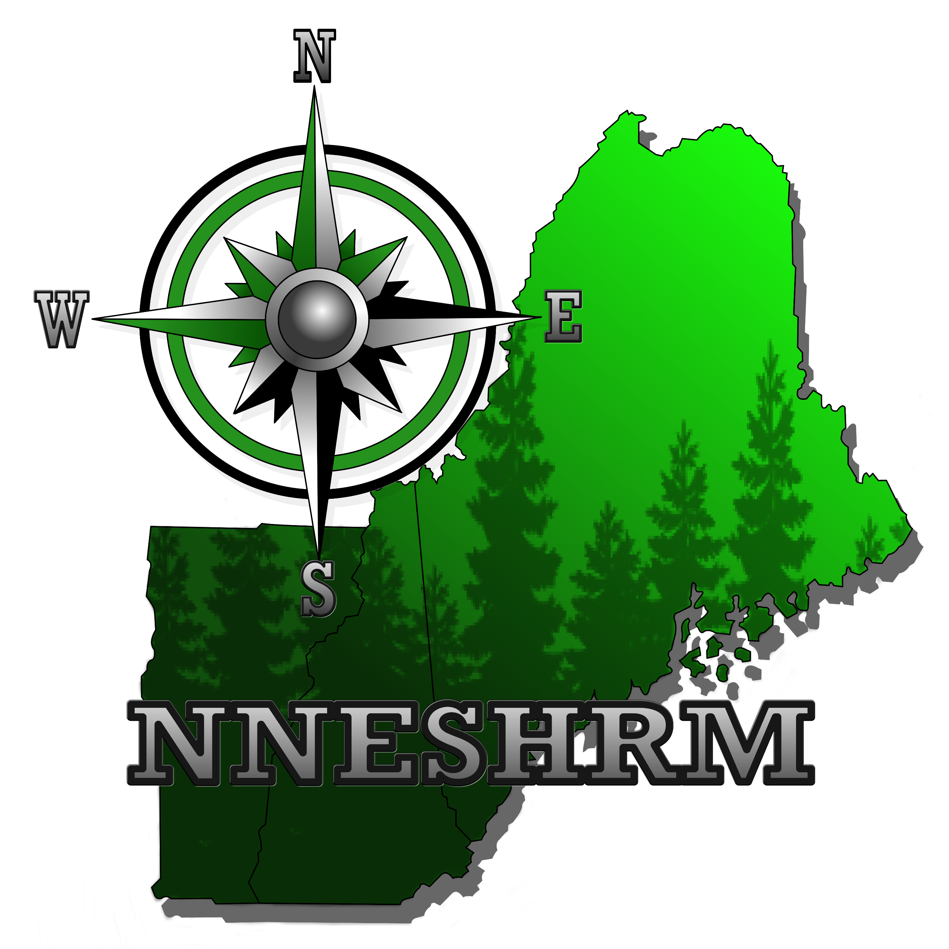

NNESHRM Sponsorship Form
Important Sponsorship Details:
- Sponsor benefits begin upon payment. If no logo is provided, the company name will be displayed.
- Sponsorship benefits are valid for one year from the commitment date, regardless of when payment is received.
- To activate complimentary memberships, sponsors must provide member names and emails.
- Memberships follow the calendar year (January–December), but NEW sponsors joining in October or later will have memberships extended through the following year.
- For sponsorship inquiries, contact sponsorship@nneshrm.org.
- For payment-related questions, contact treasurer@nneshrm.org.

Step 1: Select Your Sponsorship Level
Organization Name: |  |  |  | Date:
Our organization would like to sponsor NNESHRM at the following level:
☐ Diamond Sponsor – $2,500
☐ Platinum Sponsor – $1,750
☐ Gold Sponsor – $1,000
☐ Silver Sponsor – $500

Step 2: Annual Sponsorship Preference
☐ Option 1: Auto-renew sponsorship – An invoice will be sent in December for the following year.
Invoice Contact Information:
Name:
Address:
Email:
☐ Option 2: One-year sponsorship only – Your logo will be removed on January 15 unless you notify us of your intent to renew.

Step 3: Submit Your Logo & Website Link
Please provide your organization’s logo and website link for sponsor recognition.
Logo Upload:   |  | Website Link:

Step 4: Provide Member Details
Please list the individuals receiving NNESHRM memberships as part of your sponsorship.
Sponsorship Level | Member Name |  | Email Address
1 - Gold Level
2 - Platinum Level
3 - Diamond Level

Step 5: Submit Your Form & Payment
- Email completed form to: sponsorship@nneshrm.org
- Make checks payable to: Northern NE Society for Healthcare Risk Management
- Mail checks to:
  - Nicole Thayer
17 Old Neck Road
Scarborough, Maine 04074

